CALL TO ARTISTS – REQUEST FOR PROPOSALS
Greenville Mural Project
Uptown Greenville Utility Boxes
Applications Due: December 16, 2019

Project Description & Objective
The newly formed Greenville Mural Project, comprised of staff of the Pitt County Arts Council at Emerge, Greenville-Pitt County Convention & Visitors Bureau (Visit Greenville, NC), Uptown Greenville, East Carolina University, and members of the community invite visual and graphic artists to apply for the opportunity to submit proposals and qualifications for public art projects at various locations in the Uptown Greenville and Dickinson Avenue Districts.

The goal of the Greenville Mural Project is to facilitate the creation and execution of murals and public art installations in Uptown Greenville and the surrounding neighborhoods.
1. Design for Vinyl Wrap of Utility Box in Uptown Greenville:

Utility Box #1
Location: Fifth Street & Evans Street- the main and main of our center city, where Five Points Plaza is home to many community events and celebrations
Dimensions:
Width: 37.00" Height: 73.00" (2 North/South panels)
Width: 26.50" Height: 73.00" (2 East/West panels)

2. Design for Vinyl Wrap of Utility Box in Uptown Greenville:

Utility Box #2
Location: Fifth Street & Cotanche Street- a major intersection for nightlife and entertainment in the Uptown Greenville district.
Dimensions:
Width: 37.00" Height: 73.00" (2 North/South panels)
Width: 26.50" Height: 73.00" (2 East/West panels)

3. Design for Vinyl Wrap of Utility Box in Uptown Greenville:

Utility Box #3
Location: Reade Circle & Cotanche Street- the point where East Carolina University main campus and the Uptown Greenville businesses meet.
Dimensions:
Width: 37.00" Height: 63.00" (2 North/South panels)
Width: 26.50" Height: 66.00" (2 East/West panels)

Finalists for these locations will be chosen and will receive a $500 Honorarium for their design which will be reproduced at one proposed mural proposal locations. Funding for implementing the selected murals will be provided by the Greenville Mural Committee and partners.

ELIGIBILITY
Open to any artist or designer.

PROJECT TIMELINE
Applications Due: December 16, 2019
Finalists Selection: December 18 – 20, 2019
Installation: Late December 2019/early January 2020

HOW TO APPLY:
All necessary files must be submitted no later than Monday, December 16, 2019, via https://pittcountyarts.org/artists/artistopportunities.

ARTISTS MUST SUBMIT THE FOLLOWING:
- Project Statement: No more than 1 page including details about your design

- Artist Resume: No more than 3 pages, including contact information

- 3 Work Samples: showcasing your style and artistic merit. Previous mural experience is not required, but encouraged

- 1-3 Entries: designs for the Utility Boxes.

EVALUATION
Finalists will be chosen based on the final criteria:
- The merit of the work samples
- Artists are willing to collaborate with the Greenville Mural Project team and selected location partners to create a mural that responds to the context of the community

ADDITIONAL INFORMATION
For questions, please contact:

Holly Garriott, Executive Director of the Pitt County Arts Council at Emerge
Email: holly@pittcountyarts.org | Phone: 252-551-6947

Sierra Jones, Director of Communications & Marketing for Visit Greenville, NC
Email: sierra@visitgreenvillenc.com | Phone: 252.329.4200 ext. 4248
1. Design for Vinyl Wrap of Utility Box in Uptown Greenville:

Utility Box #1
Location: Fifth Street & Evans Street
Dimensions:
Width: 37.00" Height: 73.00" (2 North/South panels)
Width: 26.50" Height: 73.00" (2 East/West panels)
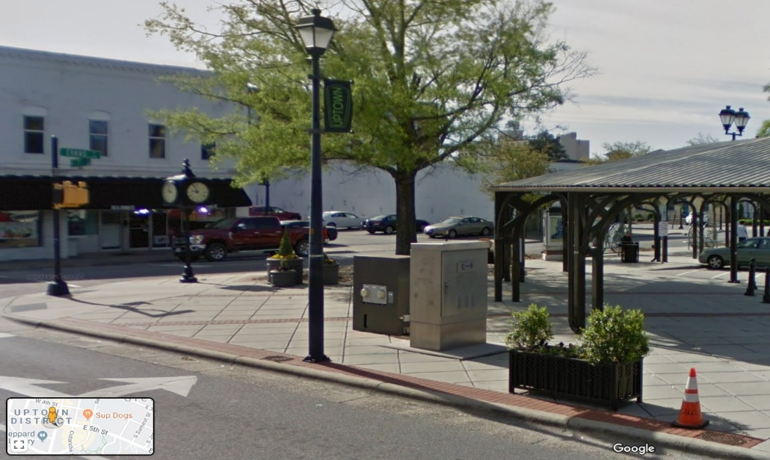

2. Design for Vinyl Wrap of Utility Box in Uptown Greenville:

Utility Box #2
Location: Fifth Street & Cotanche Street
Dimensions:
Width: 37.00" Height: 73.00" (2 North/South panels)
Width: 26.50" Height: 73.00" (2 East/West panels)

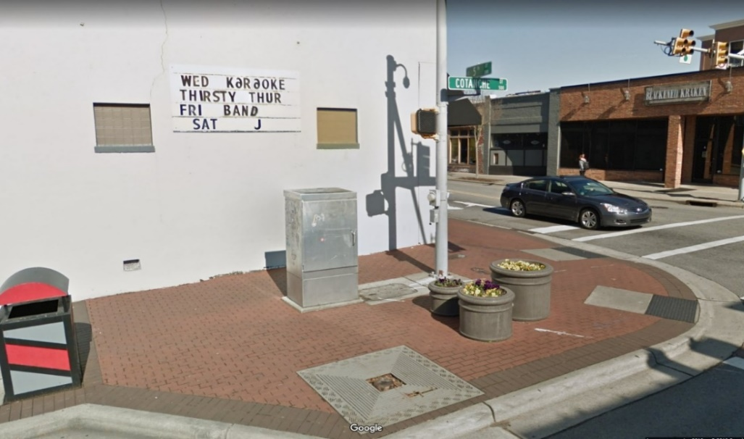
3. Design for Vinyl Wrap of Utility Box in Uptown Greenville:

Utility Box #3
Location: Reade Circle & Cotanche Street
Dimensions:
Width: 37.00" Height: 63.00" (2 North/South panels)
Width: 26.50" Height: 66.00" (2 East/West panels)

